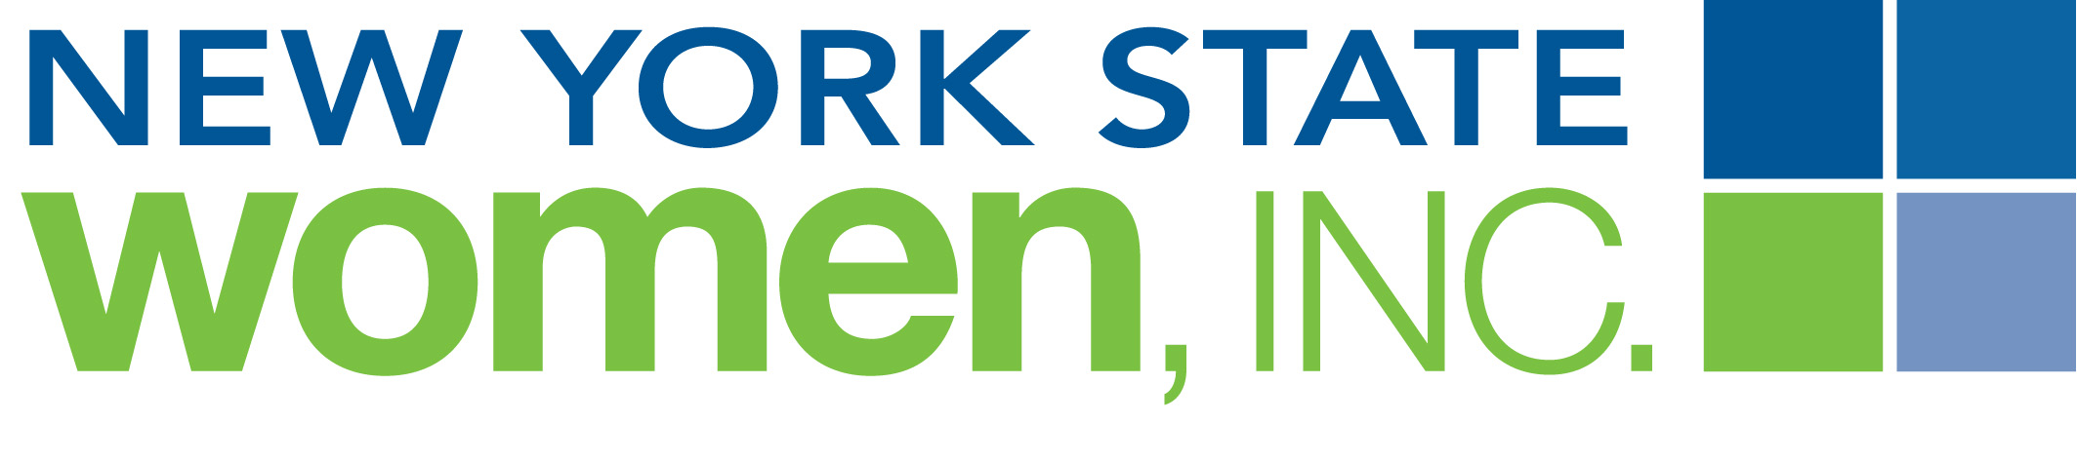

Women In Business Month

NYSW has established Women in Business Month which occurs annually each October.
We have created ads that you can use to help promote this event.
These ads, saluting "Women in Business" are for the use of NYS Women, Inc. chapters in October:
- use the ads in your chapter newsletter and emails
- place an ad in your local newspaper
- send an ad to another women's organization for publication in their newsletter
Full description of the Women In Business Week
and for the up to date information: http://nyswomeninc.org/Membership/Member-Login/Member-Information/Programming

Any questions please email PR@nyswomeninc.org

